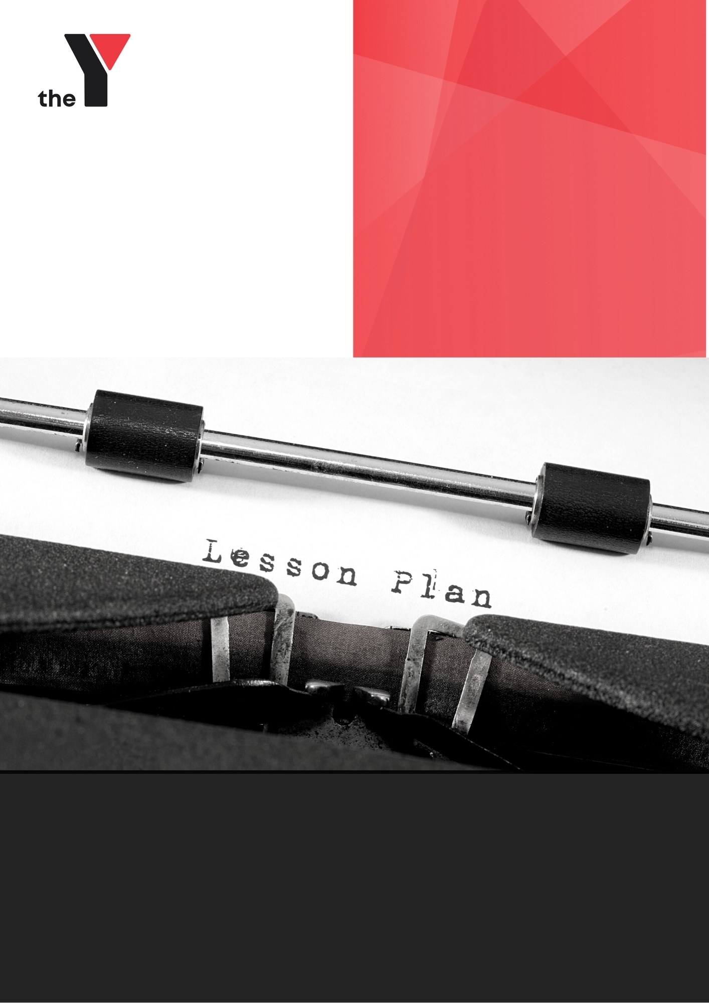
SUBJECT
NAME HERE
YMCA VOCATIONAL SCHOOLS
Lesson Plan: Learning Intention/Concept Lesson Plan
Teacher Name:
School:
Date/week: |  |  | Notional Hours:
Subject: |  |  | Class:
Cognitive Verbs to cover: |  |  | Overview of Class Needs:
Learning Intention(s): (Taken from TLAP)

Success Criteria (differentiated): What will the students be able to say they know or can do?)
Early |  | Typical |  |  | Advanced
Key Rotation Station: |  |  |  |  | Brain Break Activities
Concept/Learning Intention: | Other Learning Activity  (Include TLAP sample learning activities and specific ones for your class) |  |  | TLAP? | Further learning support/QDTP differentiation
Formative Assessment Ideas | Use in Specific Lesson? |  |  |  | Differentiation
Reflection/Comments:

